|  |  |  |  |
| --- | --- | --- | --- |
| **Coure Code:** | **ECE1002** | **Course Name:** | **Semiconductor Devices and Circuits Lab** |
| **Faculty In – Charge:** | **Dr. Pradeep Naryanan. S.** | **Department:** | **SENSE** |
| **Name of the Student:** | **Aryan Pandey** | **Registration Number:** | **20BLC1087** |
| **Experiment No.:** | **10** | **Date of Experiment:** | **14.06.2021** |
| **Name of the Experiment:** | **DESIGN A CIRCUIT TO MEASURE AND PLOT THE DRAIN AND TRANSFER CHARACTERISTICS OF A FIELD EFFECT TRANSISTOR** | | |

**OBJECTIVE:**

To design and verify the behaviour of the Field Effect transistor and observe its characteristics.

**TOOLS:**

LTSPICE XVII Simulator.

**THEORY**

Field Effect Transistor:

The field-effect transistor is a type of transistor that uses an electric field to control the flow of current. FETs are devices with three terminals: source, gate, and drain.

The concept of the field effect transistor is based around the concept that charge on a nearby object can attract charges within a semiconductor channel. It essentially operates using an electric field effect - hence the name.

There are two types of field-effect transistors, the Junction Field-Effect Transistor (JFET) and the “Metal-Oxide Semiconductor” Field-Effect Transistor (MOSFET), or Insulated-Gate Field-Effect Transistor (IGFET).

Field effects transistors (FETs) are used in mixer circuits to control low inter modulation distortions. FETs are used in low frequency amplifiers due to its small coupling capacitors. It is a voltage controlled device due to this it is used in operational amplifier as voltage variable resistors.

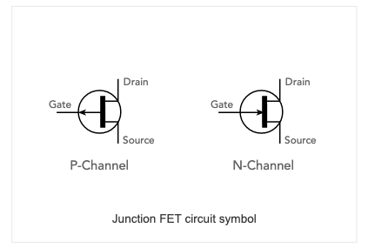

PROCEDURE

1. Draw two voltage sources and name each one of them as VGS (of gain) and VDS (of drain).
2. Then draw a NMOS Transistor from the component section and place it.
3. Using wires connect all the elements as shown in the figure below.
4. Then in edit simulation command, set the values of VDS to constant for drain characteristics and VGS to constant for gain characteristics .
5. The start time is 0 stop time is 5 and the step is 1 for both the types.
6. Use two source in DC sweep.
7. The Gain Characteristics:

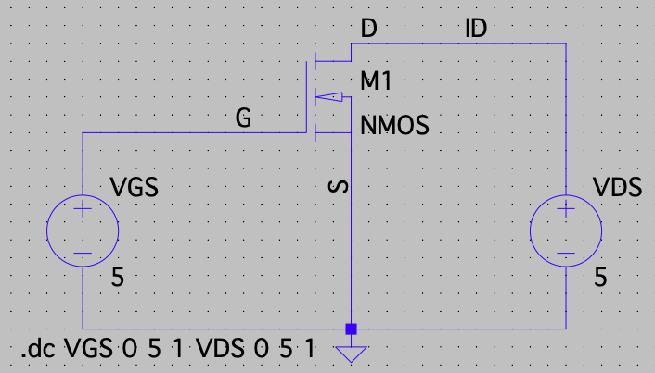

1. The Drain Characteristics: -

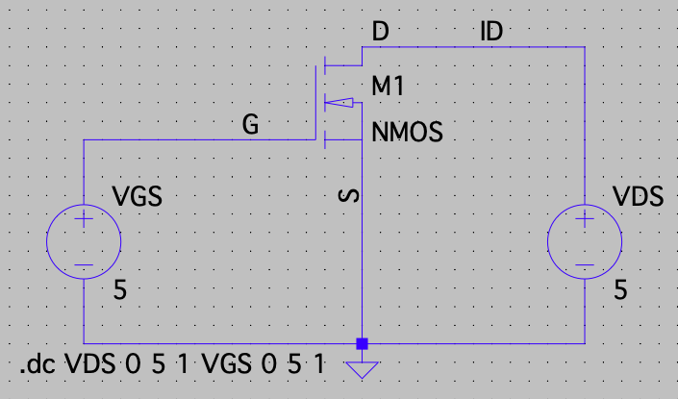

Verification of the Field Effect Transistor Drain Characteristics

Transfer Characteristics

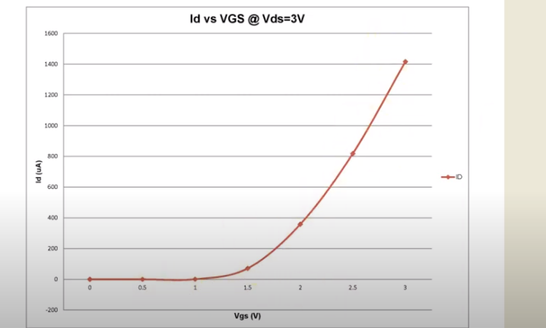

Components Required

* NMOS Transistor
* Voltmeters
* Wires
* Ground
* Label Nets

Logic Diagram: -

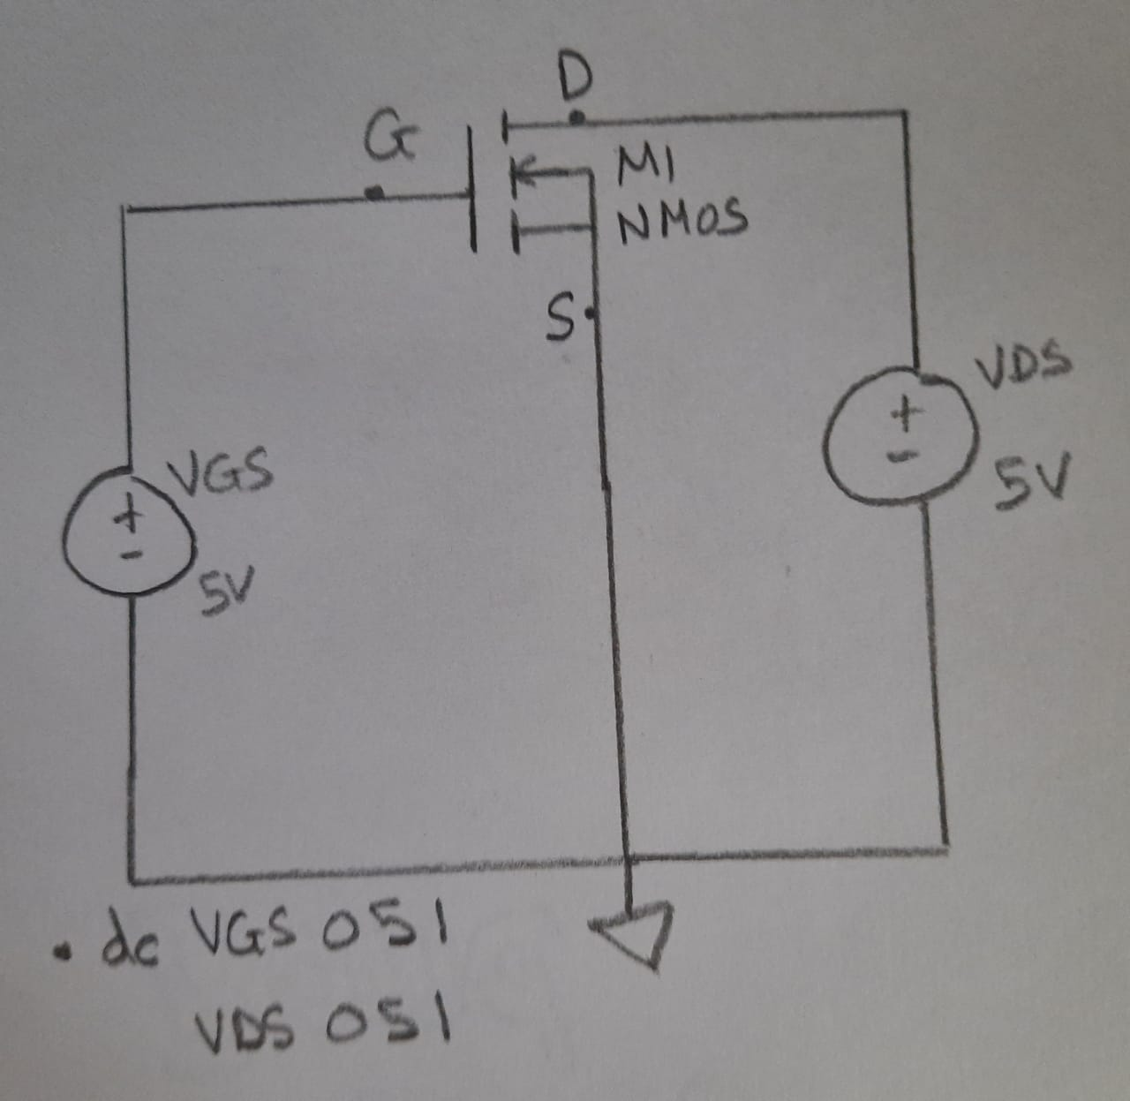

Simulator Diagram – Schematic: -



Output Waveform :

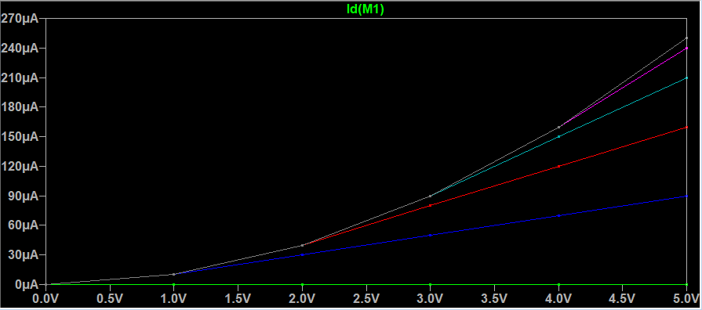

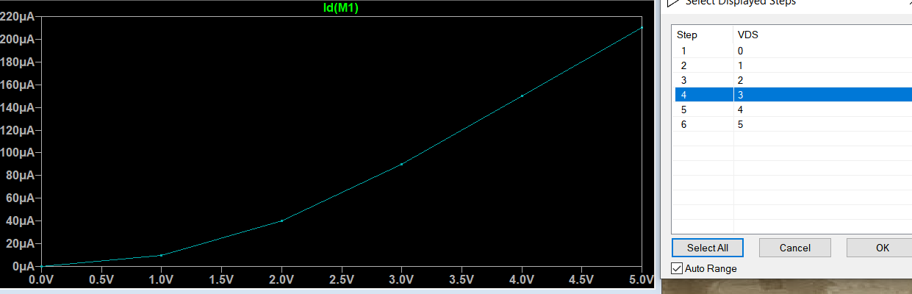

Drain Characteristics

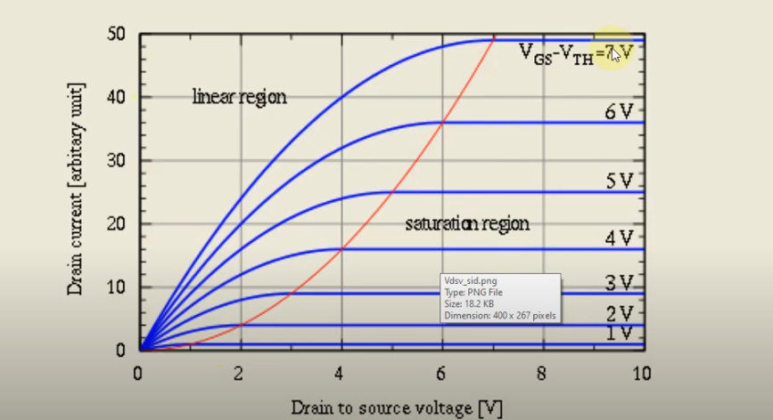

Components Required:

* NMOS Transistor
* Voltmeters
* Wires
* Ground
* Label Nets

Logic Diagram:

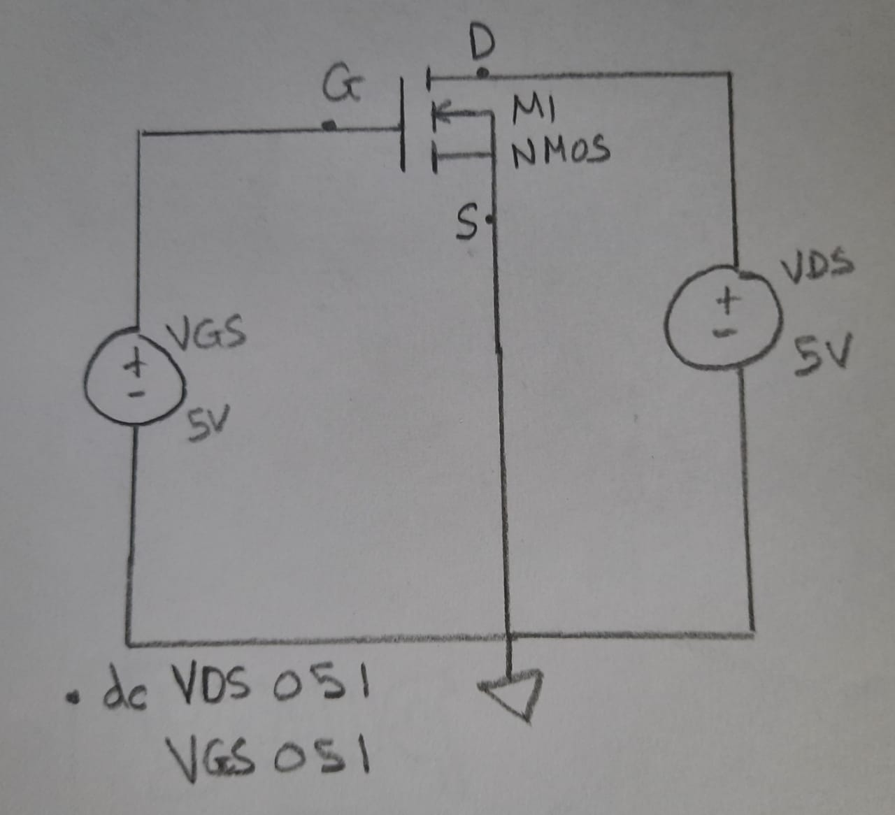

Simulator Diagram – Schematic:



Output Waveform:

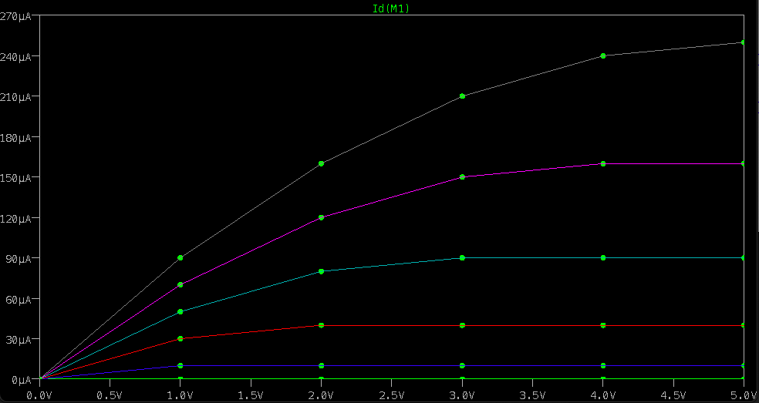

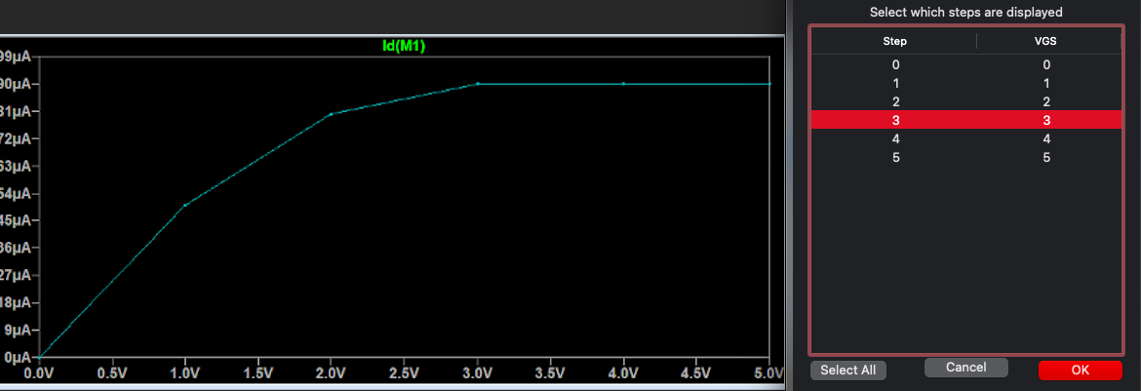

**INFERENCE**

Transfer characteristics of NMOS:

The transfer characteristic relates drain current (ID) response to the input gate-source driving voltage (VGS). Since the gate terminal is electrically isolated from the remaining terminals (drain, source, and bulk), the gate current is essentially zero, so that gate current is not part of device characteristics. The transfer characteristic curve can locate the gate voltage at which the transistor passes current and leaves the off-state. This is the device threshold voltage (VTN).

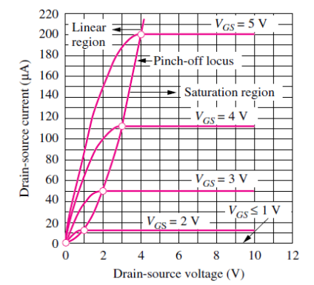

For the drain characteristics we keep the VDS as constant and plot the graph between VGS and ID. We observe that for every increase in VGS there is increase in id current too.

Keeping the VDS at constant. VDS at 1,2,3,4,5 have different single line increasing graph which is in the parameters of both id and VGS.

**RESULT:**

**DESIGN A CIRCUIT TO MEASURE AND PLOT THE DRAIN AND TRANSFER CHARACTERISTICS OF A FIELD EFFECT TRANSISTOR**